|  |  |  |  |
| --- | --- | --- | --- |
|  | <CIS355 Final Landscaping Project> | |  |
| DATE OF REQUEST | | SERVICE REQUESTED FOR DEPARTMENT(S) | |
| 11/29/2020 | | CIS355 | |

|  |  |
| --- | --- |
| SUBMITTED BY | EXECUTIVE SPONSOR |
| **Name: NathanielWilliams** | **Prof. Nana Liu** |
|  |  |
|  |  |

TYPE OF SERVICE REQUESTED:

Information Strategy Planning  Existing Application Enhancement

Business Process Analysis and Redesign  Existing Application Maintenance (problem fix)

New Application Development  Not Sure

Other (please specify **__Generate cost proposals for clients_____**

|  |
| --- |
| **BRIEF STATEMENT OF PROBLEM, OPPORTUNITY, OR DIRECTIVE**  The customer has put in a request for a lawnscaping GUI that will have these requirements:   * App has three tabs * App will compute square feet and cost * Summary (Receipt) of the collection of selected/input items * Store the information in MySQL Database |
|  |

|  |
| --- |
| **BRIEF STATEMENT OF EXPECTED SOLUTION**  An expected solution will be a GUI that is easily accessible and understandable by the end user, who can input their information reliably as they see fit. |

**Problem Analysis**

The GUI will provide three main tabs that the end user can select – Order, Receipt, Records. Order will provide information to input and select what the end user desires to be done to their yard, such as grass or gravel and input of the dimensions of the yard. Receipt will have a summary of the selected items, how much it will cost and a confirmation button, as well as a button to modify in the instance that the information is incorrect or more information is desired to be entered. Records will show the information that has been confirmed.

**Interface drawing**

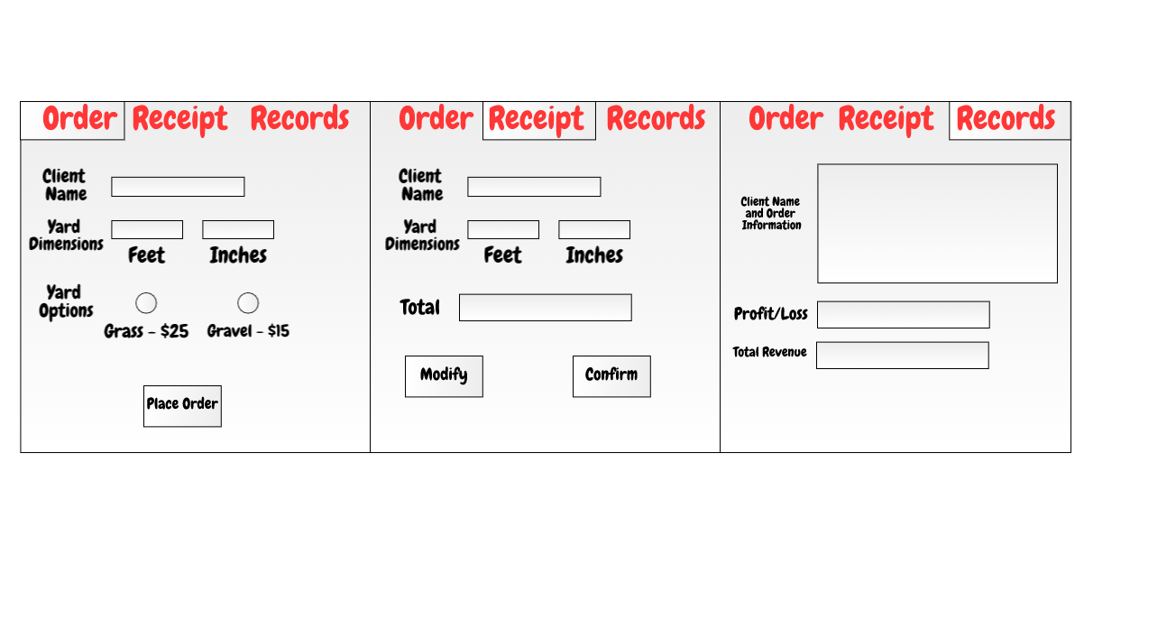

**Flowchart**

